Practical Set 1: Principles of object-oriented Programming
Practical 1.1
Code:
//1.1_25CS068
#include <iostream>
using namespace std;
class wallet
{
int id;
string name;
double balance;

public:
void setdata(int id1, string name1, double bal)
{
id = id1;
name = name1;
balance = bal;
}
void load(double x)
{
balance = balance + x;
}

void transfer(wallet &w,double money)
{
if(balance>money)
{
balance=balance-money;
w.balance=w.balance+money;

}
else
{
cout<<"Not enough Balance"<<endl;
}
}
void display()
{
cout<<"ID::"<<id<<endl<<"Name::"<<name<<endl<<"balnce::"<<balance<<endl;

}

};

int main()
{
wallet w1,w2;
w1.setdata(1,"krisha",5000);
w2.setdata(2,"Heni",5000);
w1.load(2000);
w2.load(200);
w1.transfer(w2,7000);
w1.display();
w2.display();
}

Output:

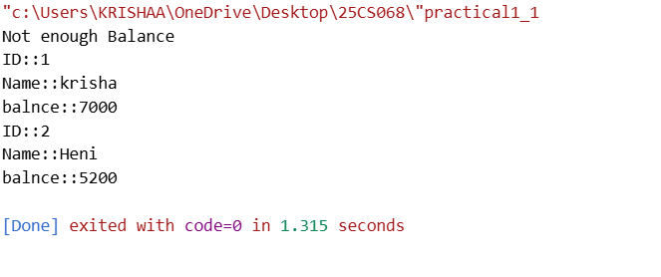

Practical 1.2
Code:

//1.2_25CS068
#include<iostream>
using namespace std;

class lib
{
int id;
string bn;
string author;
int no;

public:
void set(int id1, string bn1, string au1, int no1)
{
id = id1;
bn = bn1;
author = au1;
no = no1;
}

void addbook()
{
cout<<"Enter Book ID: ";
cin>>id;
cout<<"Enter Book Name: ";
cin>>bn;
cout<<"Enter Author Name: ";
cin>>author;
cout<<"Enter Number of copies: ";
cin>>no;
}

void issuebook()
{
if(no > 0)
{
no--;
cout<<"Book Issued"<<endl;
}
else
{
cout<<"No copies available"<<endl;
}
}

void returnbook()
{
no++;
cout<<"Book Returned"<<endl;
}

void display()
{
cout<<"Book ID is: "<<id<<endl;
cout<<"Book Name: "<<bn<<endl;
cout<<"Author Name: "<<author<<endl;
cout<<"Number Of copies: "<<no<<endl;
}
};

int main()
{
lib b;
int ch;

do
{
cout<<"1.Add Book"<<endl;
cout<<"2.Issue Book"<<endl;
cout<<"3.Return Book"<<endl;
cout<<"4.Display"<<endl;
cout<<"5.Exit\n"<<endl;
cout<<"Enter choice: ";
cin>>ch;

switch(ch)
{
case 1: b.addbook(); break;
case 2: b.issuebook(); break;
case 3: b.returnbook(); break;
case 4: b.display(); break;
}

}while(ch != 5);

return 0;
}

Output:
